Week 13 Lecture 1

Previous Lecture
- Sorting Algorithms (2)

Today’s Lecture
- Binary Search Tree
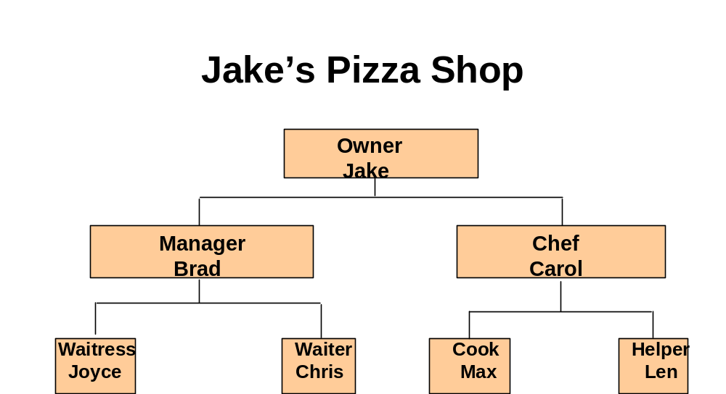
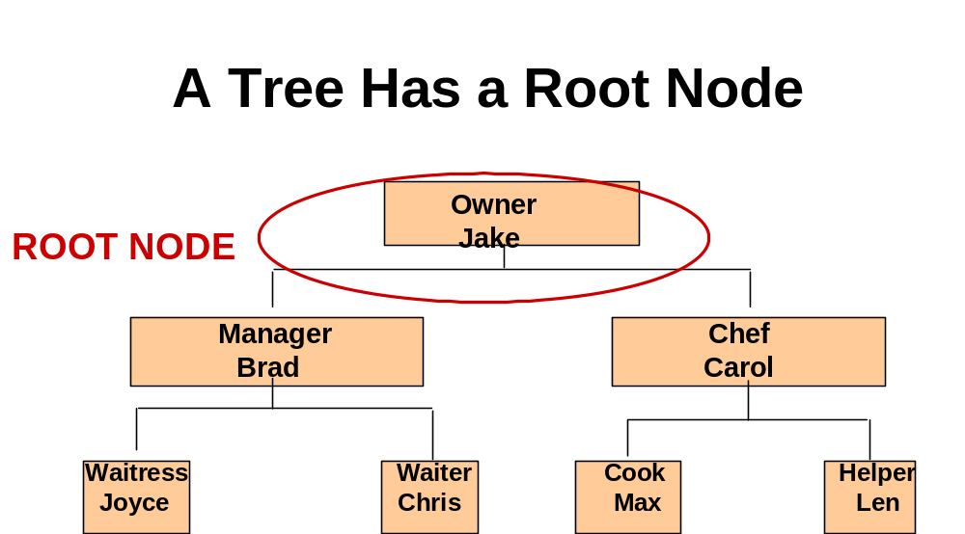
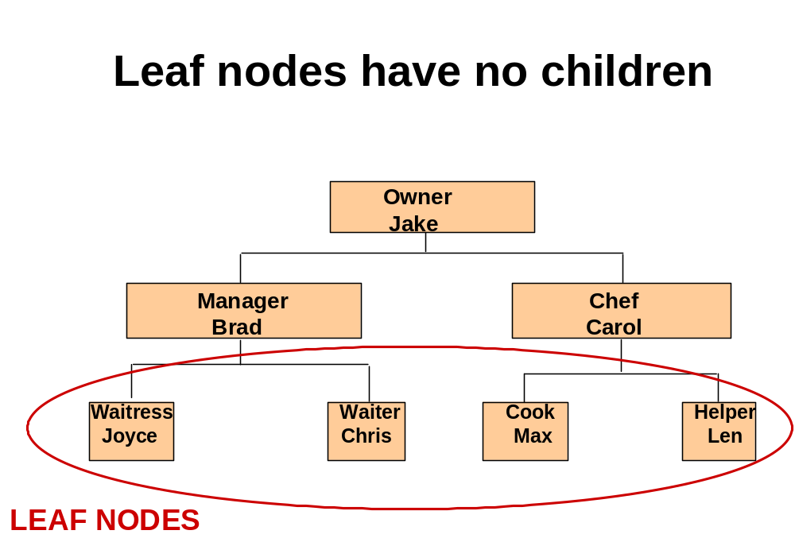
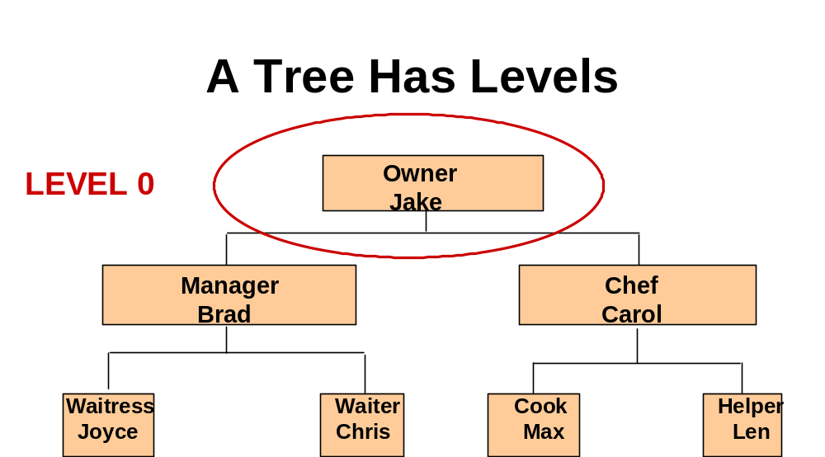
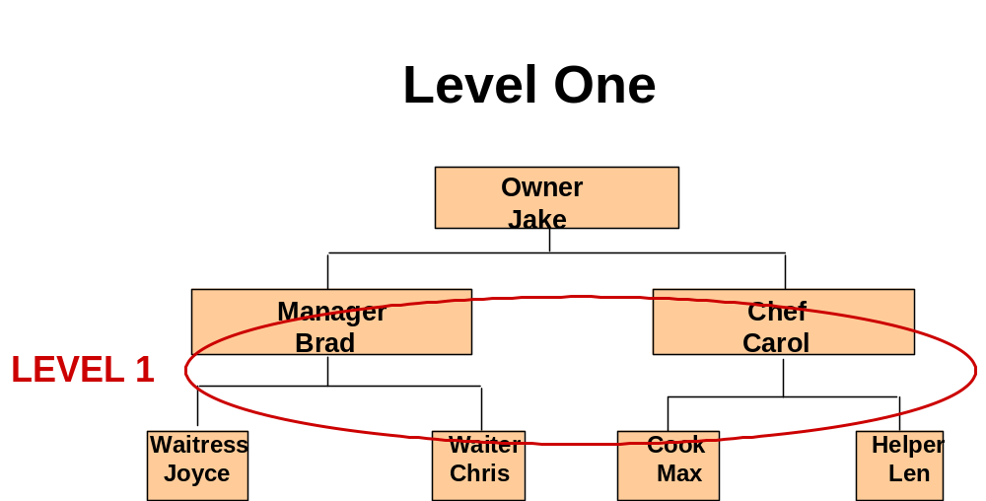
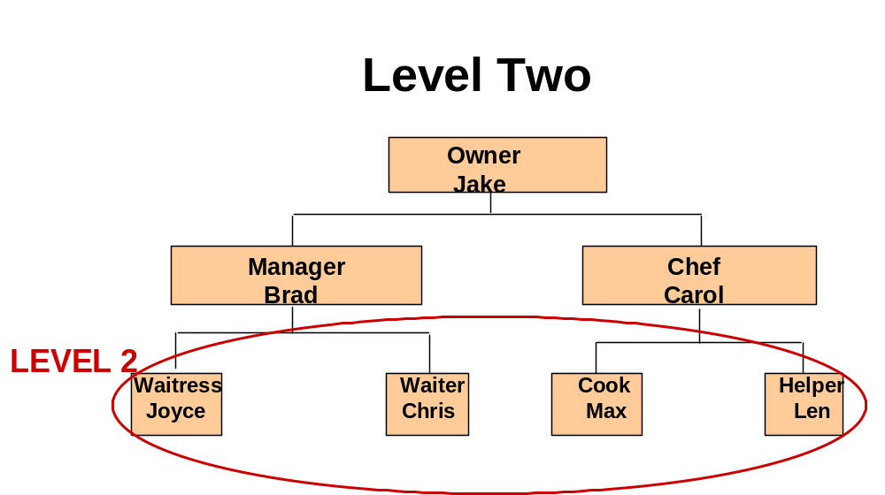
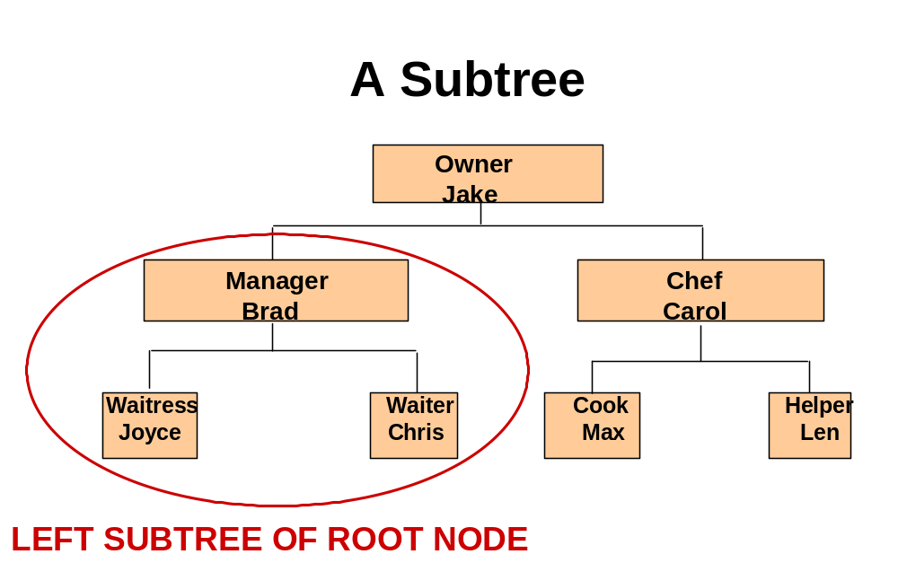
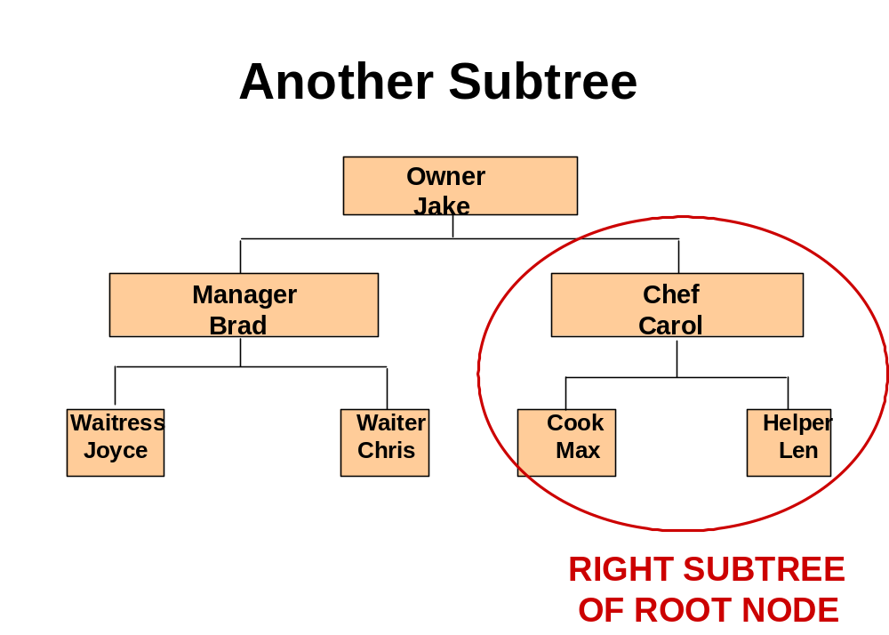
Binary Tree

A binary tree is a structure in which:

Each node can have at most two children, and in which a unique path exists from the root to every other node.

The two children of a node are called the left child and the right child, if they exist.
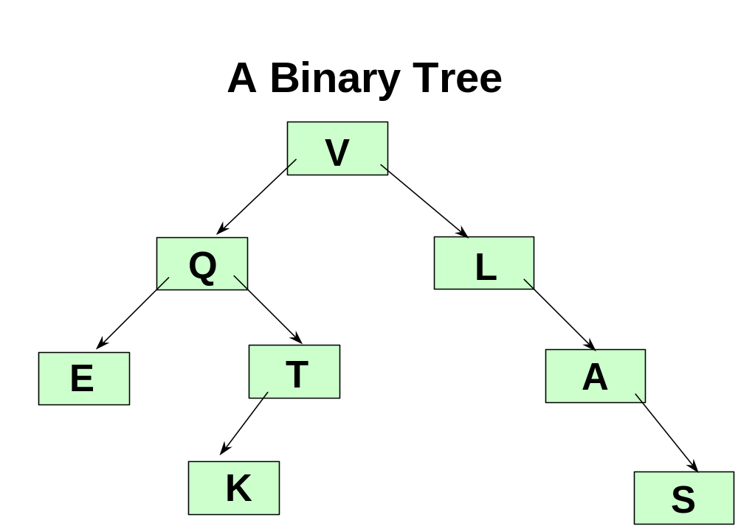
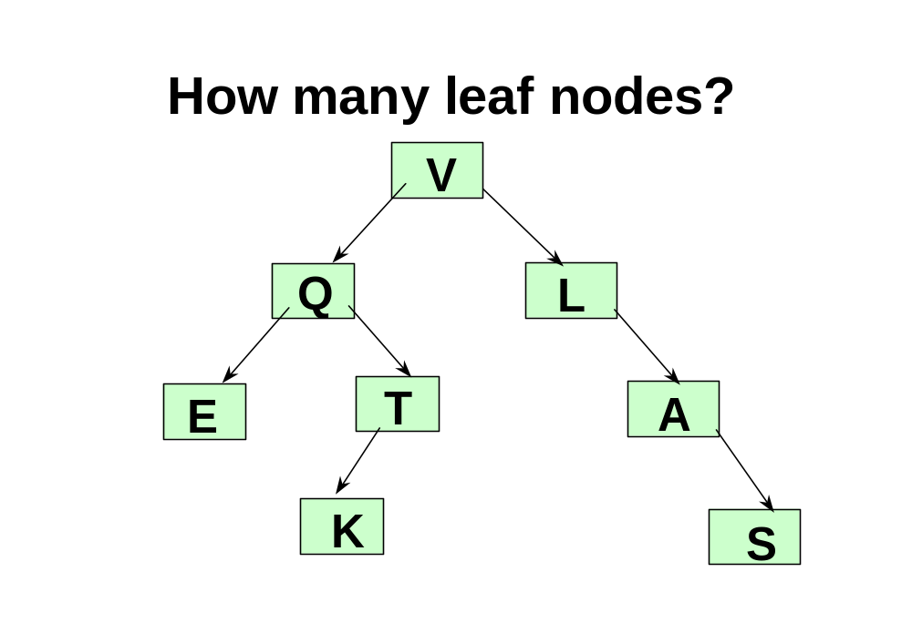
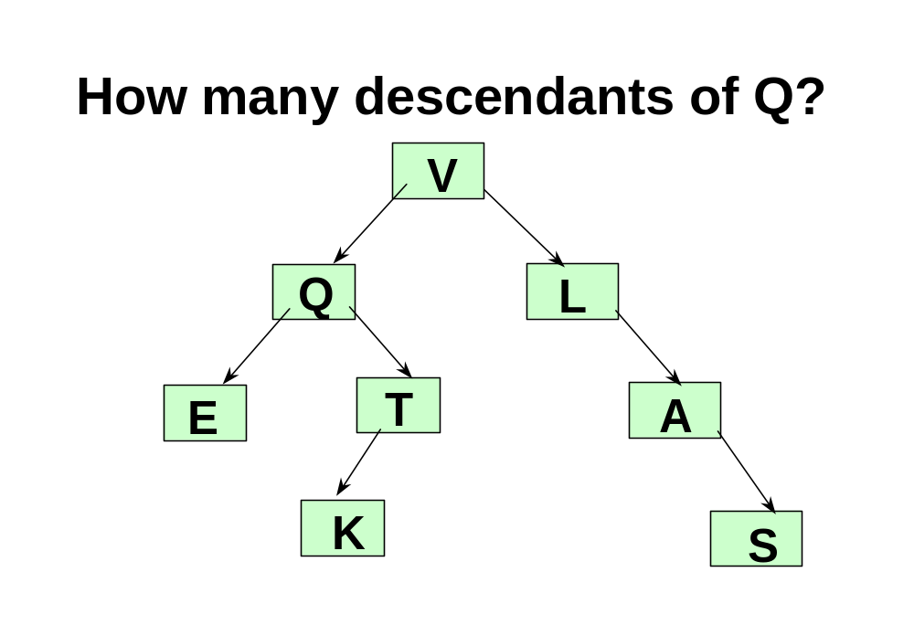
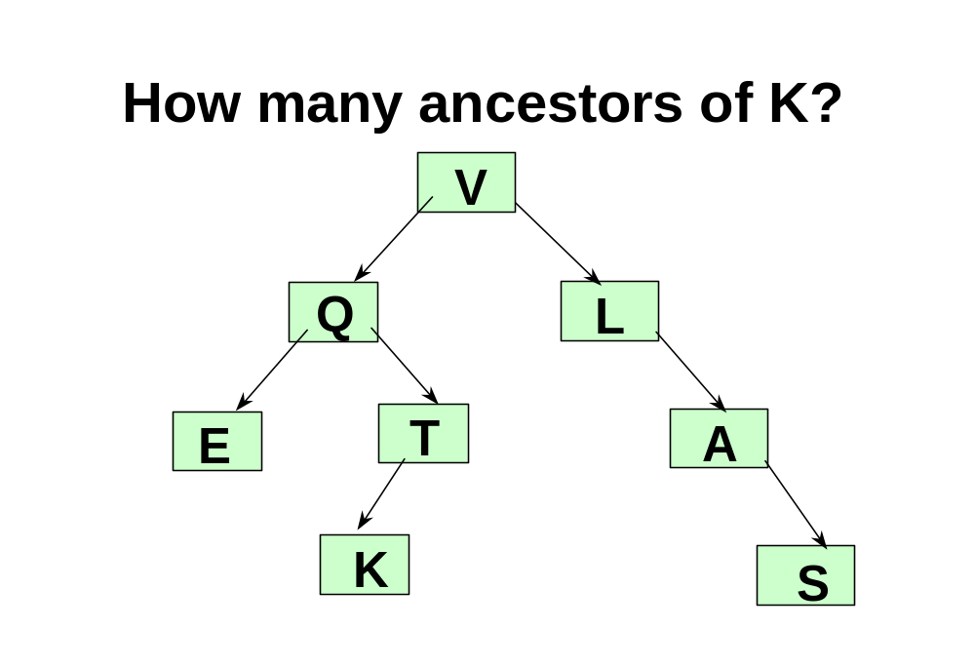
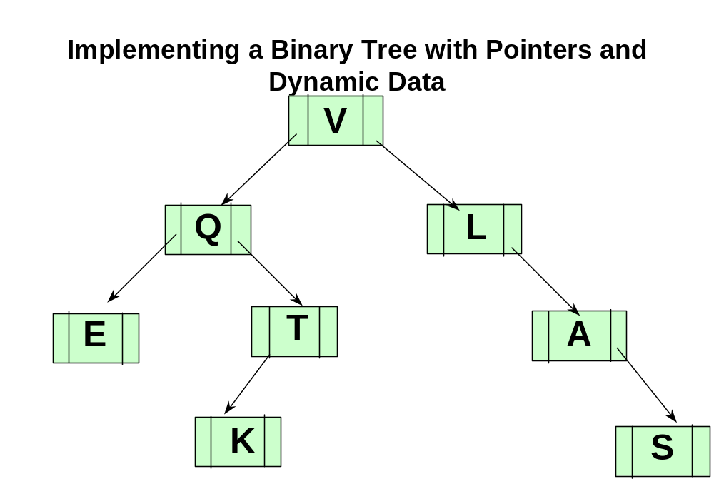
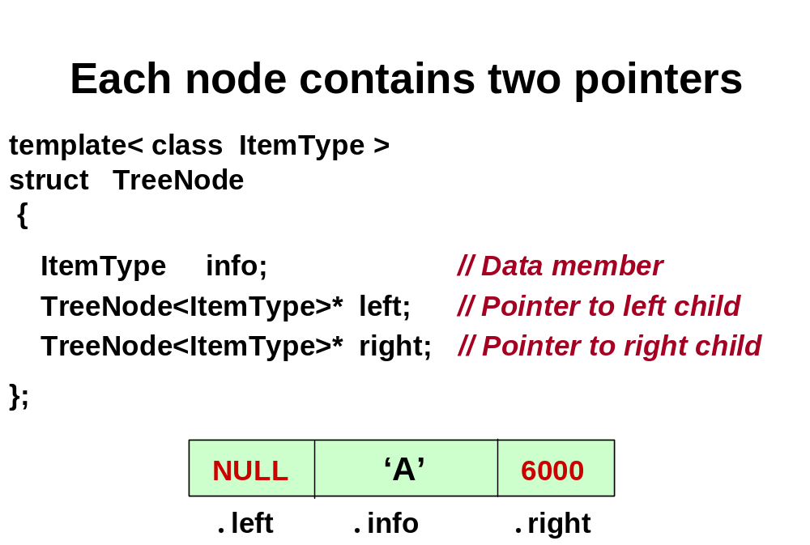
A Binary Search Tree (BST) is . . .

A special kind of binary tree in which:

1. Each node contains a distinct data value,

2. The key values in the tree can be compared using “greater than” and “less than”, and

3. The key value of each node in the tree is
less than every key value in its right subtree, and greater than every key value in its left subtree.
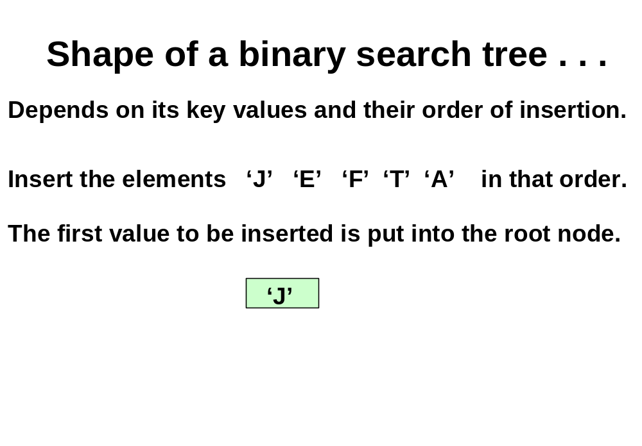
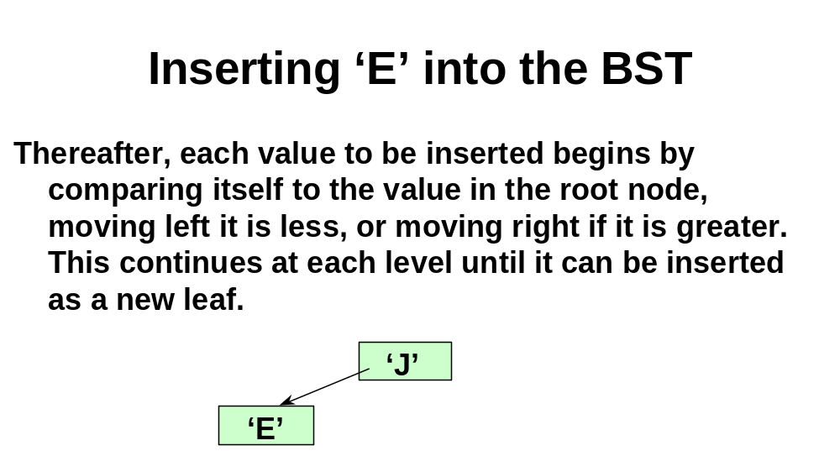
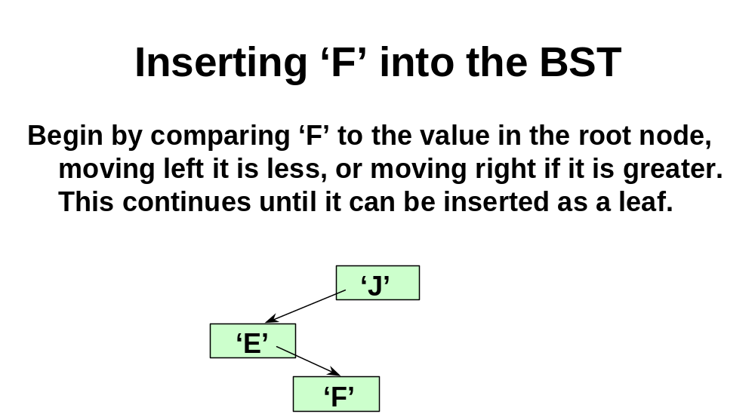
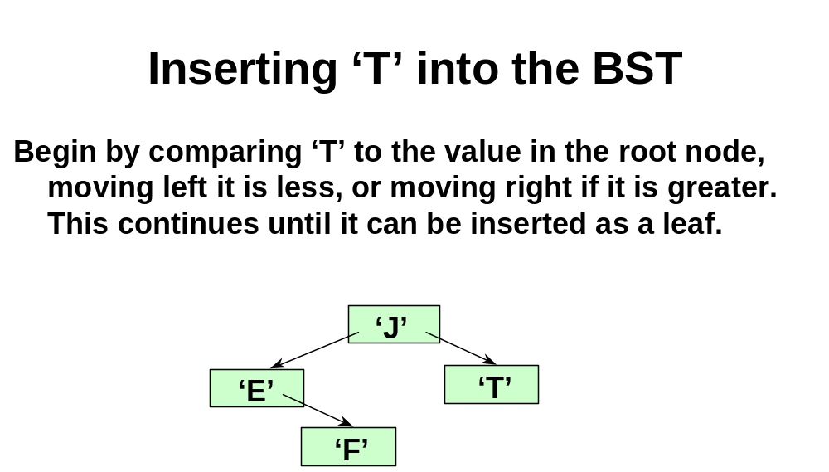

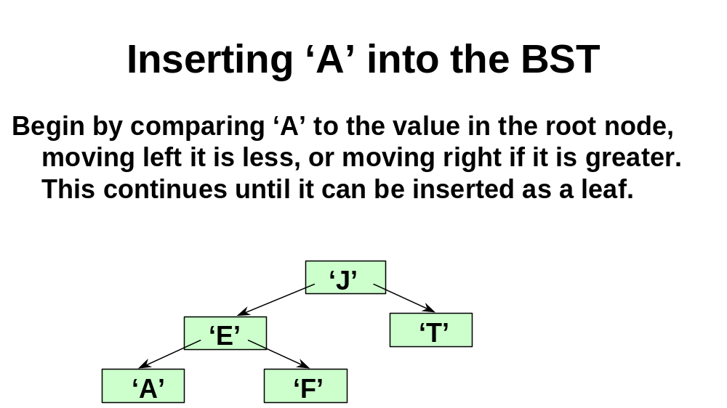
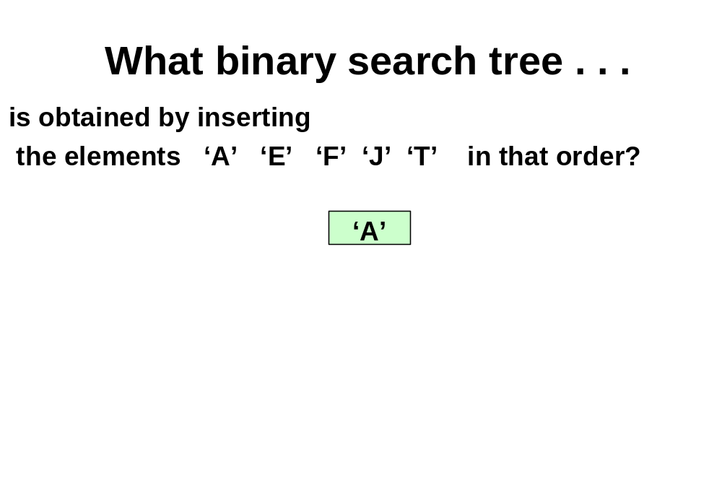
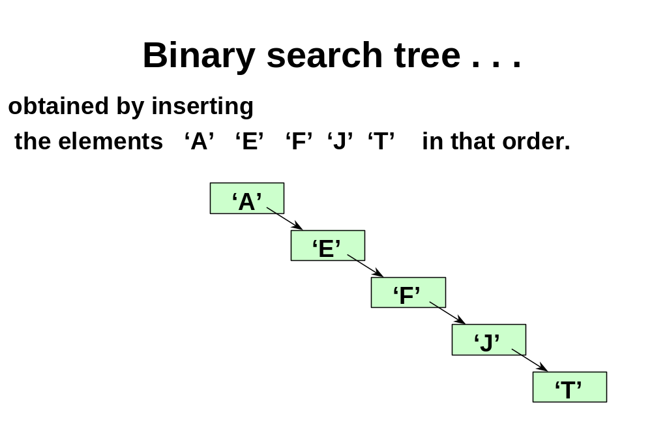
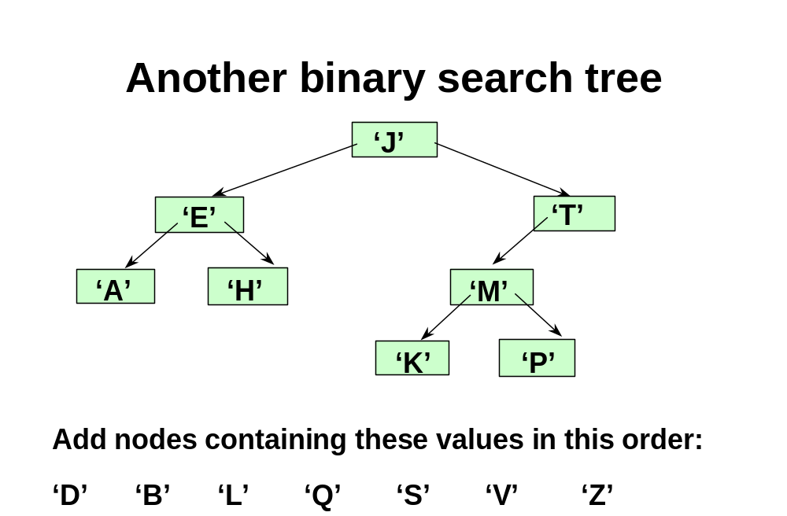
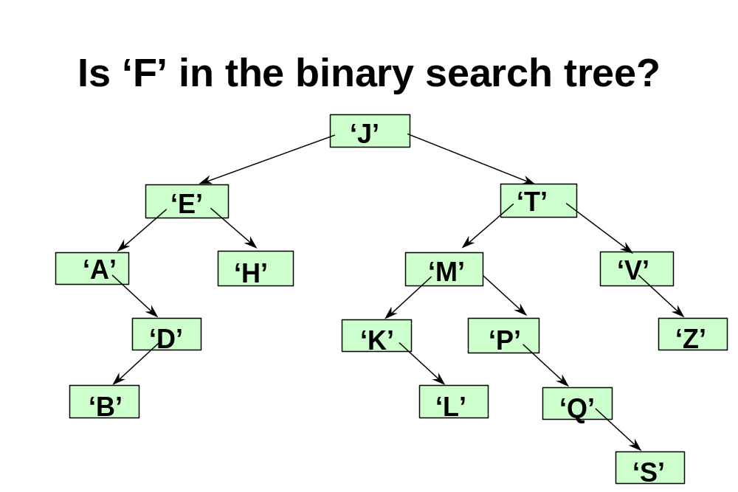
// BINARY SEARCH TREE SPECIFICATION

template< class ItemType >
class TreeType
{
public:
TreeType ( ) ; // constructor
~TreeType ( ) ; // destructor
bool IsEmpty ( ) const ;
bool IsFull ( ) const ;
int NumberOfNodes ( ) const ;
void InsertItem ( ItemType item ) ;
void DeleteItem (ItemType item ) ;
void RetrieveItem ( ItemType& item , bool& found ) ;
void PrintTree (ofstream& outFile) const ;
. . .

private:

TreeNode<ItemType>* root ;
};
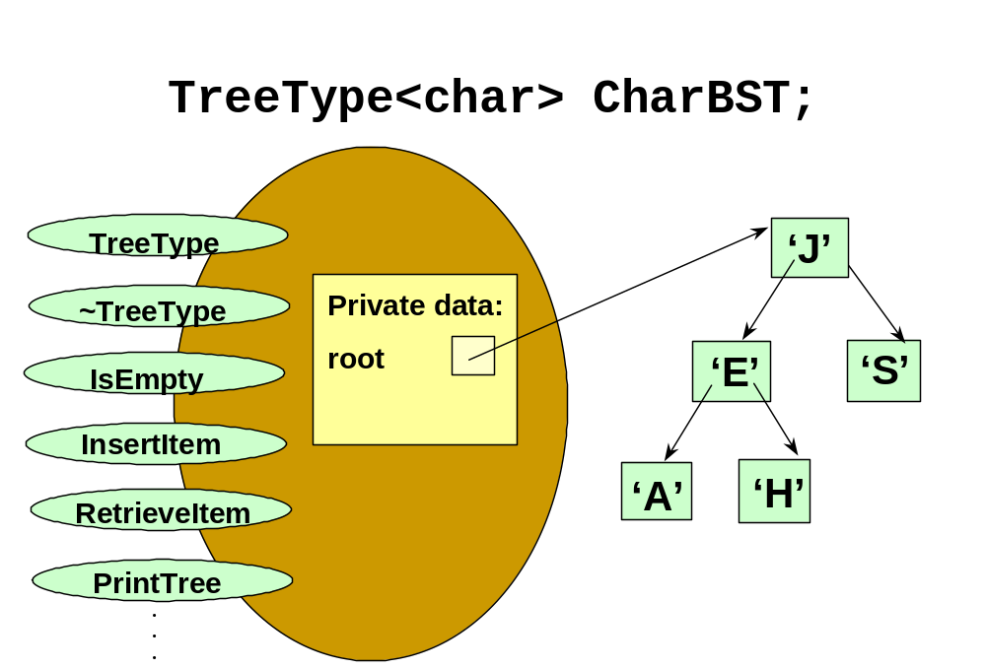
// SPECIFICATION (continued)
// - - - - - - - - - - - - - - - - - - - - - - - - - - - - - - - - - - - - - - - - - - - - - - - - - - - -
// RECURSIVE PARTNERS OF MEMBER FUNCTIONS

template< class ItemType >
void PrintHelper ( TreeNode<ItemType>* ptr,
ofstream& outFile ) ;

template< class ItemType >
void InsertHelper ( TreeNode<ItemType>*& ptr,
ItemType item ) ;

template< class ItemType >
void RetrieveHelper ( TreeNode<ItemType>* ptr,
ItemType& item, bool& found ) ;

template< class ItemType >
void DestroyHelper ( TreeNode<ItemType>* ptr ) ;

// BINARY SEARCH TREE IMPLEMENTATION
// OF MEMBER FUNCTIONS AND THEIR HELPER FUNCTIONS

// - - - - - - - - - - - - - - - - - - - - - - - - - - - - - - - - - - - - - - - - - - - - - - - - - - - - template< class ItemType >
TreeType<ItemType> :: TreeType ( ) // constructor
{
root = NULL ;
}

// - - - - - - - - - - - - - - - - - - - - - - - - - - - - - - - - - - - - - - - - - - - - - - - - - - - -
template< class ItemType >
bool TreeType<ItemType> :: IsEmpty( ) const
{
return ( root == NULL ) ;
}

template< class ItemType >
void TreeType<ItemType> :: RetrieveItem ( ItemType& item,
bool& found )
{
RetrieveHelper ( root, item, found ) ;
}

template< class ItemType >
void RetrieveHelper ( TreeNode<ItemType>* ptr, ItemType& item,
bool& found)
{ if ( ptr == NULL )
found = false ;
else if ( item < ptr->info ) // GO LEFT
RetrieveHelper( ptr->left , item, found ) ;
else if ( item > ptr->info ) // GO RIGHT
RetrieveHelper( ptr->right , item, found ) ;
else
{ item = ptr->info ;
found = true ;
}
}
template< class ItemType >
void TreeType<ItemType> :: InsertItem ( ItemType item )
{
InsertHelper ( root, item ) ;
}

template< class ItemType >
void InsertHelper ( TreeNode<ItemType>*& ptr, ItemType item )
{ if ( ptr == NULL )
{ // INSERT item HERE AS LEAF
ptr = new TreeNode<ItemType> ;
ptr->right = NULL ;
ptr->left = NULL ;
ptr->info = item ;
}
else if ( item < ptr->info ) // GO LEFT
InsertHelper( ptr->left , item ) ;
else if ( item > ptr->info ) // GO RIGHT
InsertHelper( ptr->right , item ) ;
}
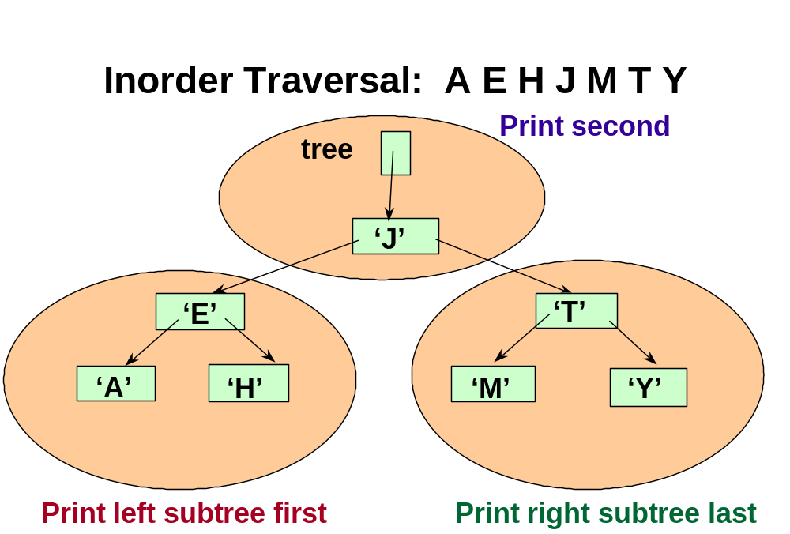
template< class ItemType >
void TreeType<ItemType> :: PrintTree ( ofstream& outFile ) const
{
PrintHelper ( root, outFile ) ;
}

template< class ItemType >
void PrintHelper( TreeNode<ItemType>* ptr, std::ofstream& outFile )
{ if ( ptr != NULL )
{
PrintHelper( ptr->left , outFile ) ; // Print left subtree

outFile << ptr->info ;

PrintHelper( ptr->right, outFile ) ; // Print right subtree

}
}
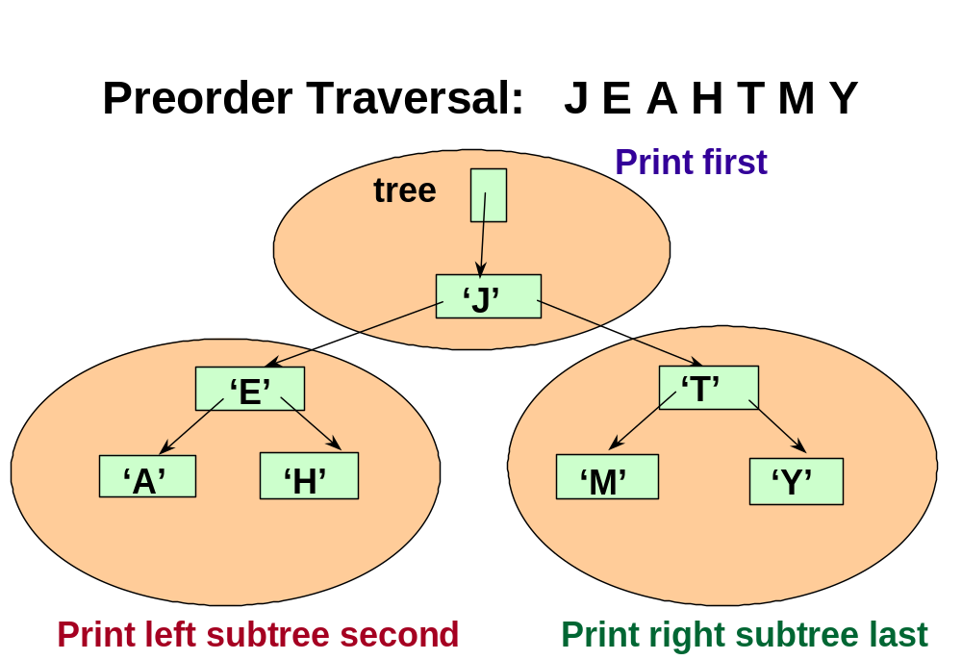
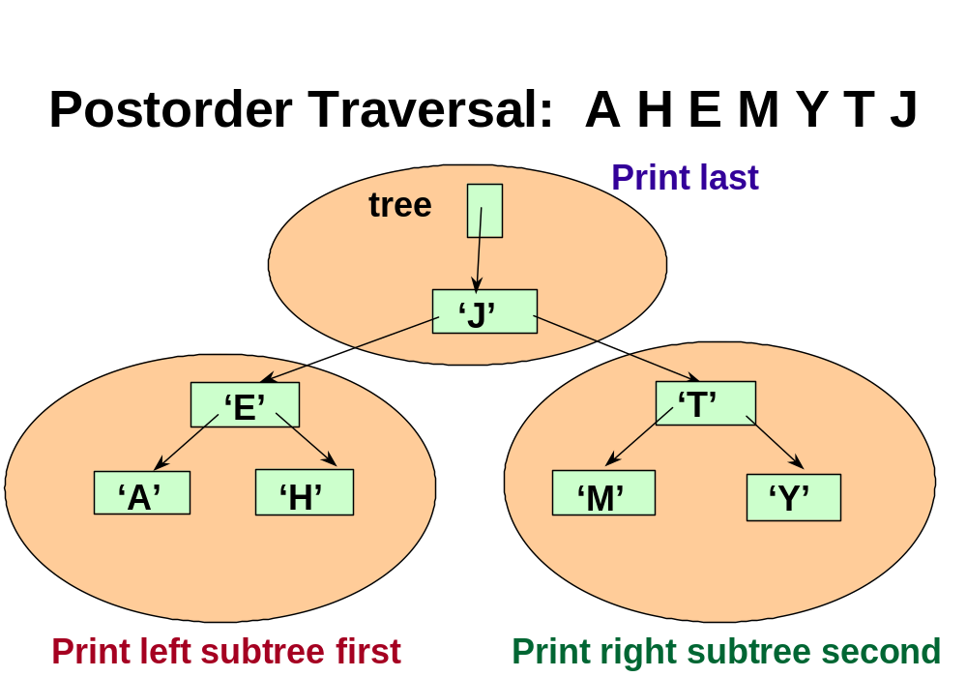
template< class ItemType >
TreeType<ItemType> :: ~TreeType ( ) // DESTRUCTOR
{
DestroyHelper ( root ) ;
}

template< class ItemType >
void DestroyHelper ( TreeNode<ItemType>* ptr )
// Post: All nodes of the tree pointed to by ptr are deallocated.

{ if ( ptr != NULL )
{
DestroyHelper ( ptr->left ) ;
DestroyHelper ( ptr->right ) ;
delete ptr ;
}
}

Today’s Lecture

- Binary Search Tree

Next Lecture

- Review of Final

